**Ultimate Highschool GPA Calculator Tutorial**

|  |  |  |
| --- | --- | --- |
| Name of Task | Instructions | Pictures |
| Login Page | 1. Enter Username 2. Select a Personal Picture |  |
| Adding a subject | 1. Go to the menu 2. Select subjects 3. Select add subject |  |
| Adding an Assignment | 1. Select a subject 2. Click the Floating Button again, and then select add category. 3. Then Click the floating button and press add category option 4. Select the category name by clicking on the image. 5. Specify a percentage Weightage for that category. (Make sure that the percentage for categories all add up to a 100%, and that you have no categories with the same name) 6. Select add category. 7. Go back to the Assignments Screen by clicking the back button. 8. Click the floating menu button and select add assignment. 9. Type in the details and click add assignment. |  |
| Adding a category | 1. When you are showed a list of all the categories, select add category. 2. Tap the image icon, to choose a custom icon for the category 3. Type the name of the category, and hit enter 4. Select the category you just added. |  |
| How to check what you need for you next assignment to get the desired grade | 1. Click the floating action button, and select Improve Your GPA. 2. Select the category of the next assignment. 3. Enter the Desired grade. |  |
| How to change the Conversion/GPA Tables | 1. Tap the menu button and select conversion Tables. 2. Select the Custom GPA Button. 3. Tap on any of GPA Conversions 4. Follow the exact format provided or the app may not work. |  |

*What to do in case the calculations don’t work according to plan, or the app malfunctions?*

1. *Restart App*
2. *Press the Refresh Button on Main Screen*
3. *Try updating the default year and semester.*
4. *Try adding more data (like subjects).*
5. *Contact me at devulnahar@gmail.com*

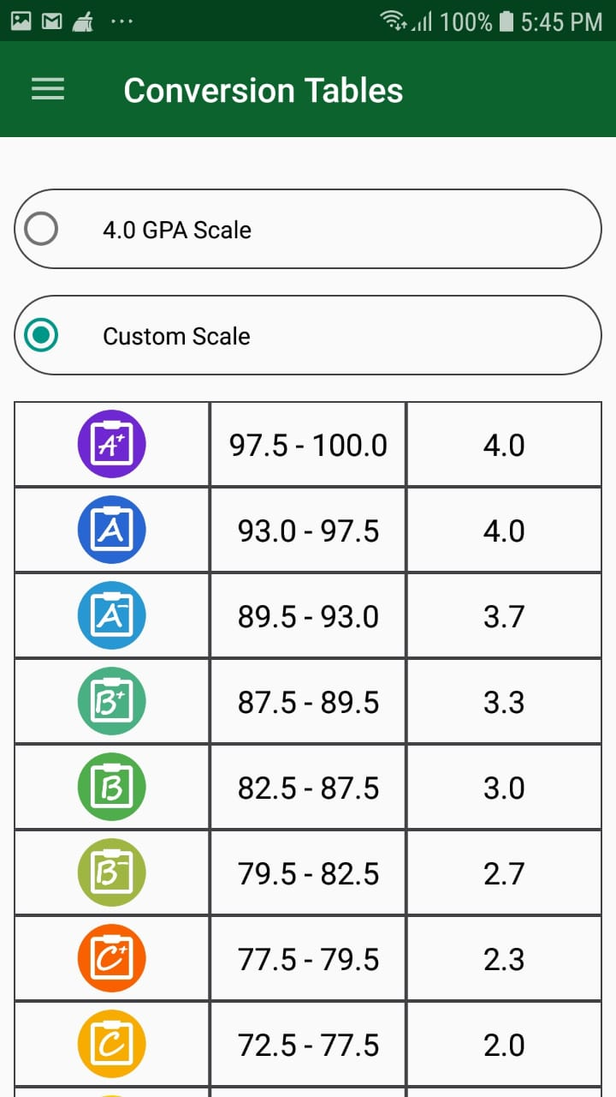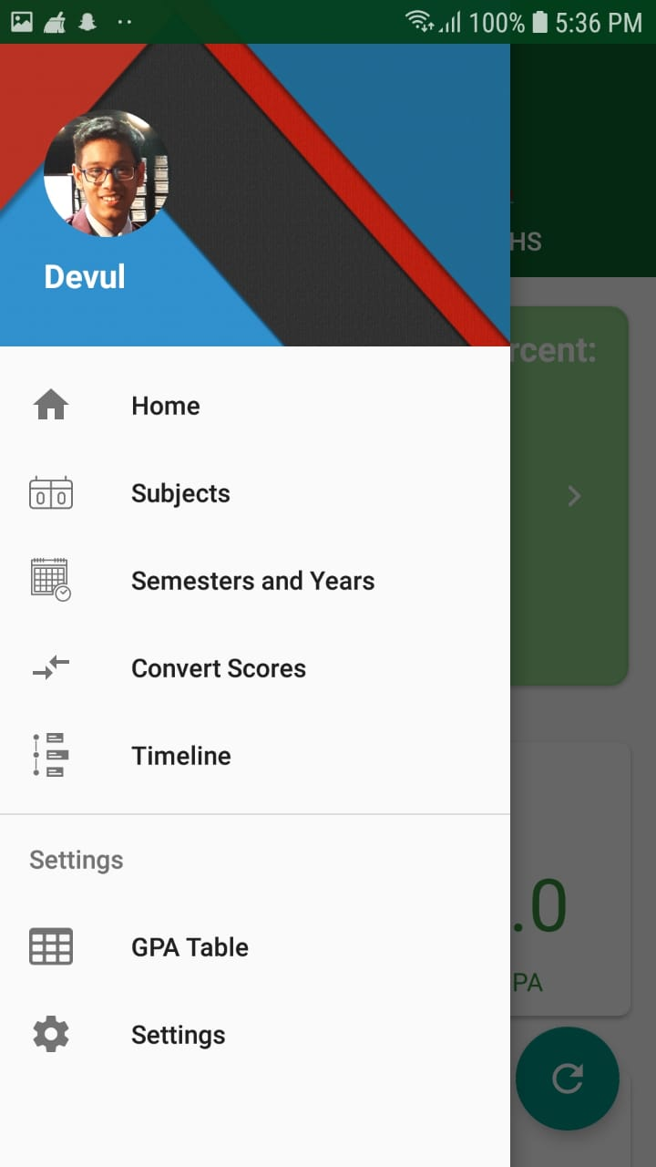



**A**



